iSeries Admin

This document will hold notes on the topic of the iSeries.

**Password reset** **1**

**Enable a disabled profile** **2**

# Password reset

To change a user’s password you can issue the following command.

**CHGUSRPRF USRPRF(THAT_GUY) PASSWORD(yaddayadda)**

# Enable a disabled profile

At times the user “Log” would be set to disabled. The following shows you how to re-enable it.

Sign on using QSECOFR/umbr3lla

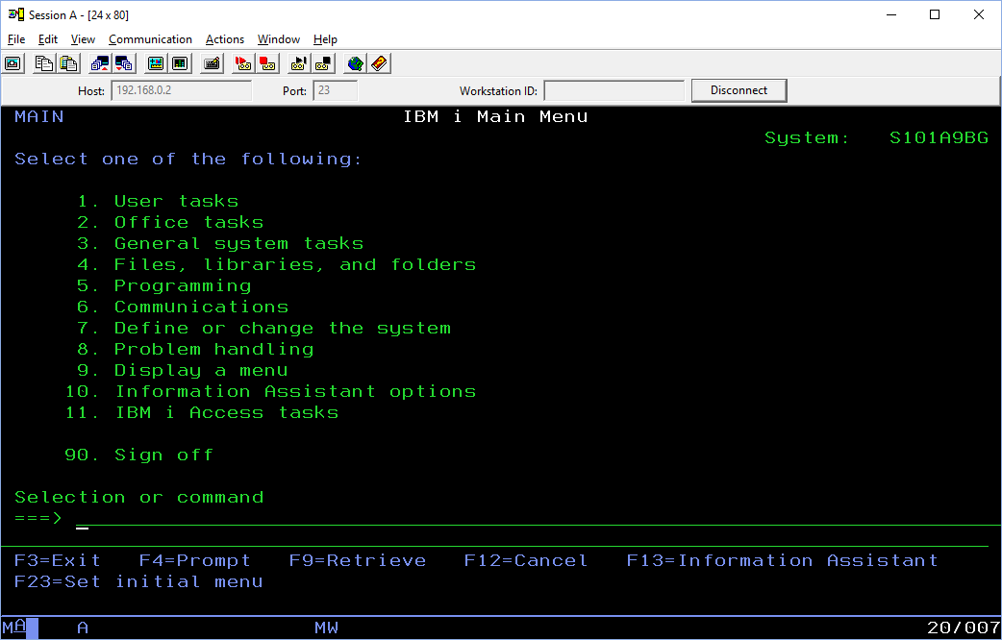

Working with user profiles by typing the command and pressing F4.

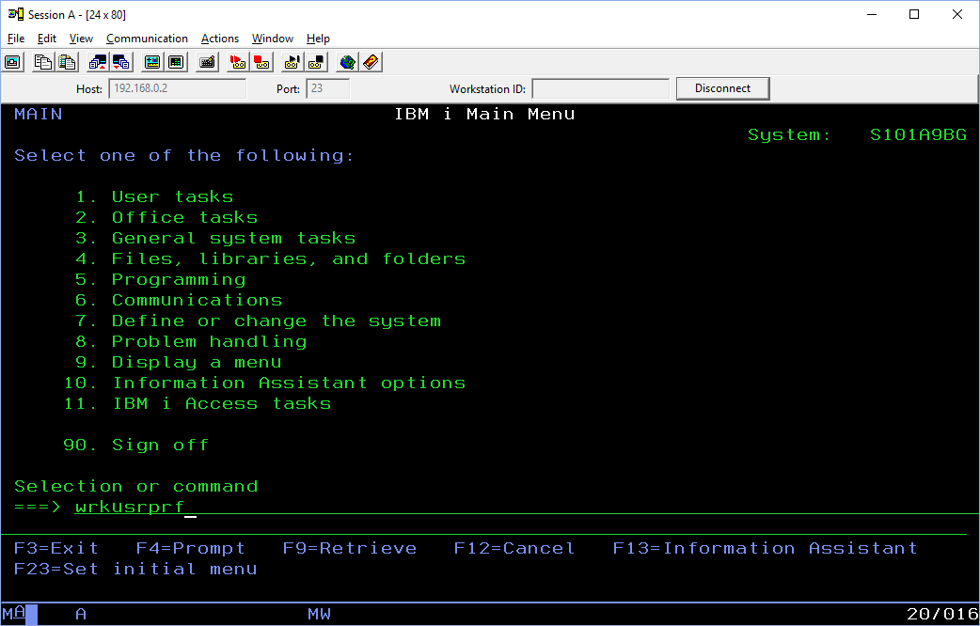

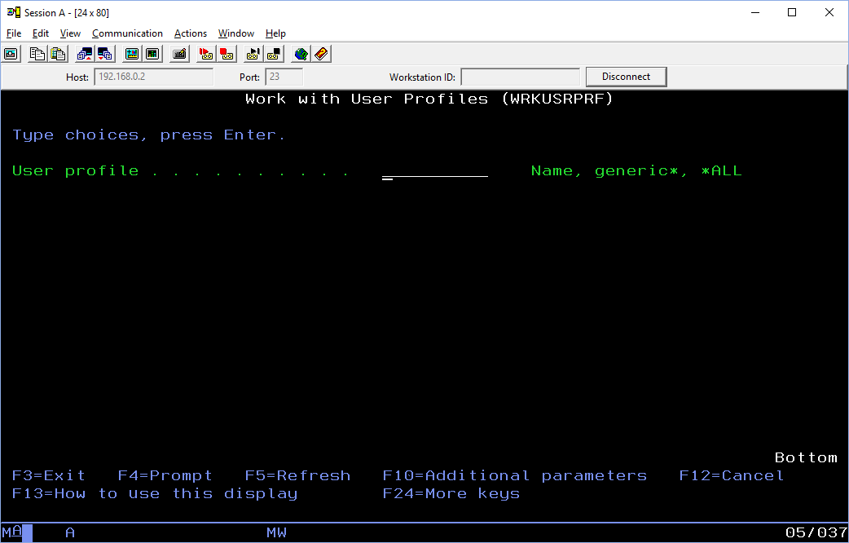

Now you can select users, type *all.

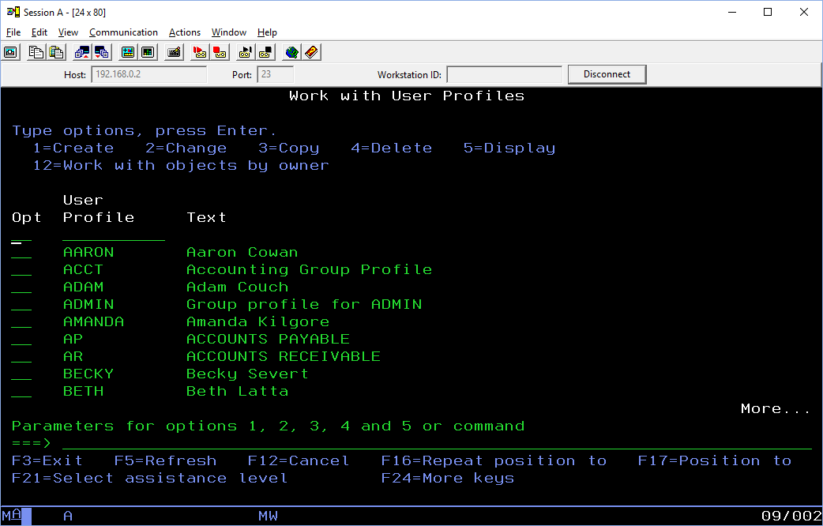

You select from this list.

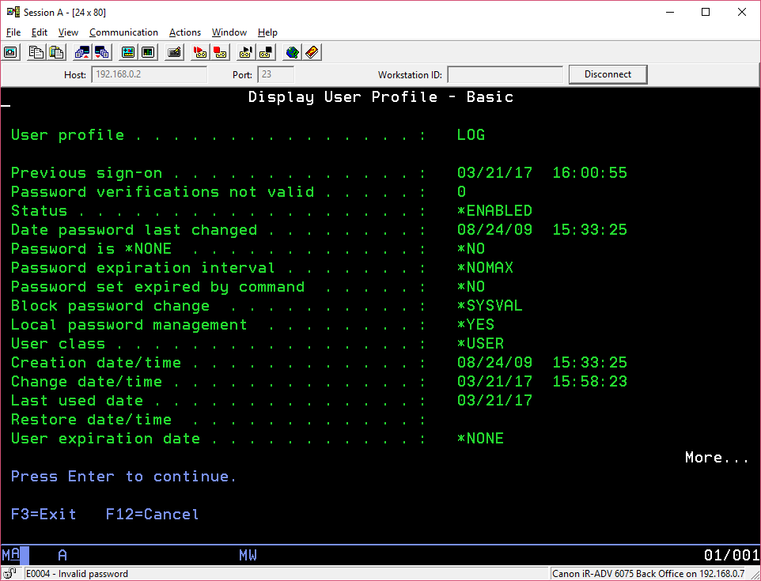

For the user id log you may need to reset Password expiration interval to *NOMAX.